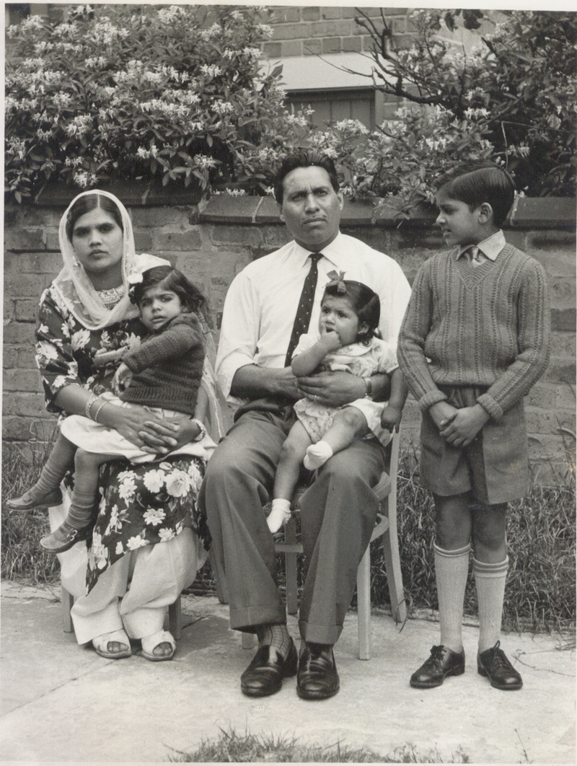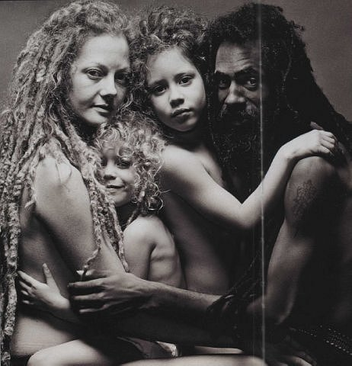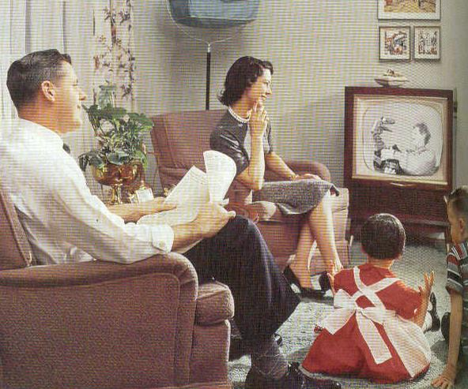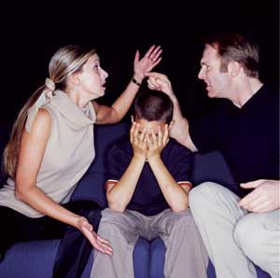
Sociology of Marriage and Family
Sociology 3638-090: Summer 2013
University of Utah
Location: Canvas (somewhere in cyber space)
May 13 – June 19, 2013
3 Credit Hours

Instructor:

Daniel Poole
Office Hours: By appointment
Email: daniel.poole@soc.utah.edu

Course Description:

In this course we will examine marriages, families, and intimate relationships through a sociological lens. We will use several different sociological theories to explore these concepts. In order to paint a full picture of these relationships we will use a variety of media including academic texts, popular music, film, and other materials.

Required Text:

Williams, Brian K., Stacey C. Sawyer, and Carl M. Wahlstrom. 2012. Marriages, Families, and Intimate Relationships: A Practical Introduction. (2nd Edition). Pearson.

Course Requirements:

In order to ensure lively conversation, students are expected to actively participate in online discussions by posting and responding to discussion threads. Specific details on how to do this will be provided at the beginning of the course. Quizzes will be completed online and will cover the required reading material and/or the media we watch or listen to.

You will also be expected to complete 2 short projects. The first will provide you with the chance to explore websites and data regarding families, children, and relationships. The second project is a short paper that will provide you with the opportunity to explore stressors in your life and to create management strategies.

Grading Criteria

Online Discussions 40%
Online Quizzes 30%
Projects 30% (15% for each project)

Grades will be calculated as follows: 100-90 =A; 90-80 =B; 80-70 =C; 70-60 =D; below
60 =F; within each range, 0 to 2.99 will earn a minus, 7 to 9.99 will earn a plus.

Accommodations for Students with Disabilities

The University of Utah seeks to provide equal access to its programs, services and activities for people with disabilities. If you will need accommodations in the class, reasonable prior notice needs to be given to the Center for Disability Services, 162 Union Building, 581- 5020 (V/TDD). CDS will work with you and the instructor to make arrangements for accommodations.

Faculty and Student Responsibilities:

“All students are expected to maintain professional behavior in the classroom setting, according to the Student Code, spelled out in the Student Handbook. Students have specific rights in the classroom as detailed in Article III of the Code. The Code also specifies proscribed conduct (Article XI) that involves cheating on tests, plagiarism, and/or collusion, as well as fraud, theft, etc. Students should read the Code carefully and know they are responsible for the content. According to Faculty Rules and Regulations, it is the faculty responsibility to enforce responsible classroom behaviors, beginning with verbal warnings and progressing to dismissal from class and a failing grade. Students have the right to appeal such action to the Student Behavior Committee.”

“Faculty...must strive in the classroom to maintain a climate conducive to thinking and learning.” PPM 8-12.3, B.“Students have a right to support and assistance from the University in maintaining a climate conducive to thinking and learning.” PPM 8-10, II. A.
- Undergraduate Council Syllabus Guidelines 2008

Course Schedule:

This is a session length course that will be held from May 13 to June 19, 2013. Specific deadlines and timetables will be provided online.

*This syllabus is subject to change at any time. Updates will be sent via email and/or announced in class and will be considered as obligatory as the information in the original syllabus.

Please contact me with any questions. Learning in the online environment can create new challenges and opportunities. I am here to help and glad to do so!

